|  |  |  |  |
| --- | --- | --- | --- |
| Description: Description: S:\AdminShared\All Staff\1 College Logo's\Baldivis_Logo_colour.jpgName: | \_\_\_\_\_\_\_\_\_\_\_\_\_\_\_\_\_\_\_\_\_\_\_\_\_\_\_\_\_\_\_\_\_\_\_\_\_\_\_\_\_\_\_\_\_\_\_\_\_\_\_ | | Date: *\_\_\_\_\_\_\_\_\_\_\_* |
|  | **Year 11 Applications**  **Test 3, 2019**  **Topics – Pythagoras, Perimeter, Area, Surface Area and Volume** | | 53  = % |
| **Total Time:** | ***55*** *minutes* |  | |
| **Total Reading:** | *3**minutes* |
| **Total Working:** | *53**minutes* |
| **Weighting:** | *4% of the year,8% of the semester.* |
| **Equipment:** | *SCSA Formula Sheet; 1 page notes (A4 one side,* ***Unfolded****), CASIO ClassPad; Scientific Calculator* | | |

**Resource Free Section – 9 min 1 min reading time [9 marks]**

**1. [3 marks: 2, 1 marks]**

Consider the pentagonal prism shown below. The area of the uniform cross section is 43cm2.

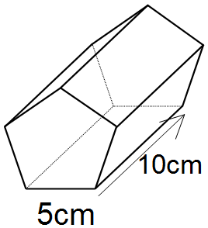

1. Calculate the surface area of this prism
2. Calculate the volume of this prism.

**2. [1 mark]**

A square has a perimeter of 48 cm. What is the area of the square?

**3. [2 marks]**

To get from point A to point B you must avoid walking through a pond.  To avoid the pond, you must walk 4 metres south and 3 metres east.  To the *nearest* *metre*, how many metres would be saved if it were possible to walk through the pond?

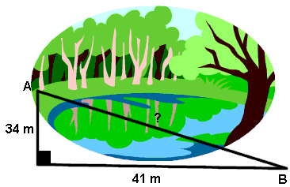

4m

3m

**4. [3 marks]**

Explain and show how you would work out the area of the shape below, you do not need to give the answer but must show which shapes, formulas and lengths are being used.

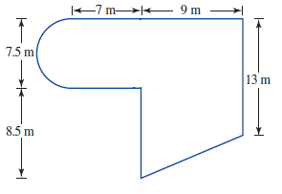

**Resource Section – 44 min 2 min reading time NAME: [44 marks]**

 **5. [7 marks: 2, 2, 3 marks]**

Calculate the perimeter and the area of each of the following. Show all working.

**a)**

Perimeter = \_\_\_\_\_\_\_\_\_\_\_\_\_\_ Area = \_\_\_\_\_\_\_\_\_\_\_\_\_\_

**b****)**

Perimeter = \_\_\_\_\_\_\_\_\_\_\_\_\_\_ Area = \_\_\_\_\_\_\_\_\_\_\_\_\_\_

**c)**

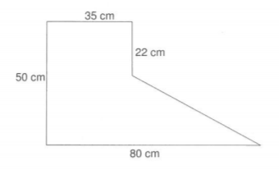

Perimeter = \_\_\_\_\_\_\_\_\_\_\_\_\_\_ Area = \_\_\_\_\_\_\_\_\_\_\_\_\_\_

**6. [4 marks]**

What is the side length of a cube that has the same surface area as a sphere with a radius of 30 cm?

**7. [9 marks]**  
Tennis balls are stored in a cylindrical container with a diameter of 4 cm as shown in the diagram. The tennis balls fill the entire vertical space of the container.

1. 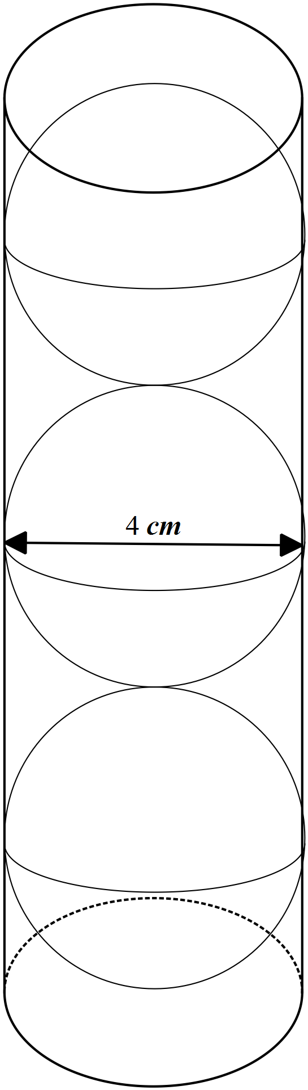Calculate the total volume of all the tennis balls

1. Calculate the volume of the container

1. Calculate the amount of unused space inside the container

1. The material used to make the container costs 2.50 cents/cm2.   
   Calculate the cost of making the tennis ball container, including the lid.

**8. [2 marks]**

Craig is marking out a rugby pitch. Craig starts at point A and goes 30 metres West, then North 70 metres, then East 100 metres and then South 15 meters when he runs out of paint. How far, to the nearest metre, is Craig from his starting point A?

**9. [6 marks: 2, 2, 2 marks]**

The curved area of a cone is 380 cm2 and the slant height is 15 cm.

 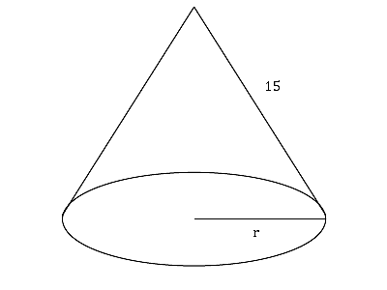

*h*

(a) Find the base radius, r, of the cone, correct to 2 decimal places.

(b) Find the perpendicular height, *h*, of the cone, correct to 1 decimal place.

(c) Find the total surface area of the cone, correct to the nearest whole number.

**10. [3marks]**

Find the capacity of the drinking glass pictured below to the nearest ml.

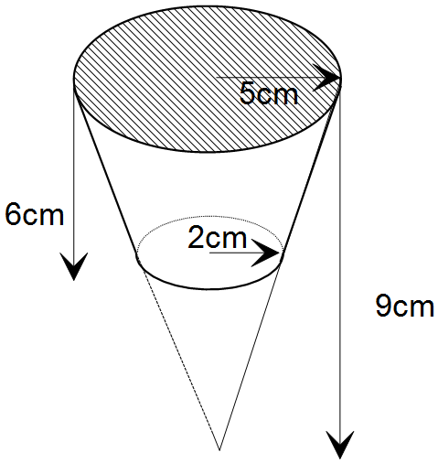

**11. [6 marks: 2, 4 marks]**

A narrow pool, designed for laps, is installed in a front garden. The pool is deeper at one end than the other.



1. Determine the length of the bottom of the pool. Round to 4 decimal places.
2. Determine the number of kilolitres of water required to fill the pool given one kilolitre = 1 m3.

**12. [3 marks]**

Consider the square based pyramid that has a perpendicular height of 12 cm and base length 10 cm.

Let *M* be the midpoint of *BC.* Determine the length of *MP.*



**13. [4 marks: 2 , 2 marks]**

The Department of Roads has a machine that lays bitumen road at a rate of 20 metres in length every 15 minutes. The bitumen is 6m wide and the machine works 7 hours per day. The department is building a road12.5km long

1. How long will it take to complete the road? State your answer in both hours and days, correct to two decimal places
2. What will the total area of bitumen laid by the machine?

-END OF TEST-